Seeing That Frees
EDITS AND REFLECTIONS
for the 2016 revised edition

p.52, footnote 7:
Oops, made a mistake in my Pali translation, etymology, and spelling (!) of ekaggatā.
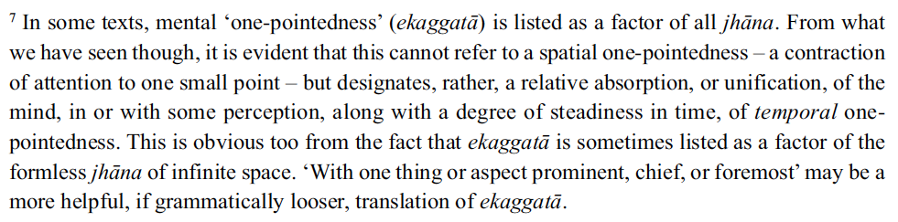

p.365, second paragraph:
The changes here may seem subtle but I feel they are very important. The original paragraph was, I came to realize, a little too vague in parts. It’s been tweaked and improved once already, but as it reads now it captures more accurately and succinctly what I really wanted to convey. This last version brings out much more precisely a couple of crucial philosophical points that are congruent with and central to the whole trajectory of the book’s project: using subtle conceptuality in meditation to understand dependent origination in a practical way and at a very deep level; and through that, taking conceptual understandings or ‘explanations’ to their absolute limits and then beyond. Wrapped up with this, the rewording also brings out some of the limits of the perspectives of conventional reality; and shows how the division between the ‘conventional’ and the ‘ultimate’ can be seen to dissolve as practice gets deeper.

I also took the opportunity to reinforce something already spelled out elsewhere (in the ‘About Time’ chapter, and earlier in this second ‘Dependent Origination’ chapter, and perhaps in a few other spots): Whether we are conscious of it or not, a notion of a next moment – in which any sense of self or subject will somehow be invested – is usually implicit just in perceiving a present moment of experience; and this is part of what drives and sustains the dynamic and sense of bhava, ‘being’.
Because of space constraints I had to try to convey and explain all this with a very limited number of words, so the resulting paragraph is quite dense with meaning. It would have been easier, probably for everyone, if I had been able to take a page at least and unpack more of what is meant in those short condensed phrases. Actually this is the case in many places in Seeing That Frees. And together with the fact that it does not repeat in slightly different words ideas at the same level very much at all – a kind of repetition that is quite common in a lot of more ‘academic’ books – it makes Seeing That Frees a relatively ‘dense’ book, and one that asks the reader to work a little harder, to be more involved, in reading it than perhaps they might with most other books. But this book would have been awfully long if it had taken that easier route, and it’s long enough as it is!
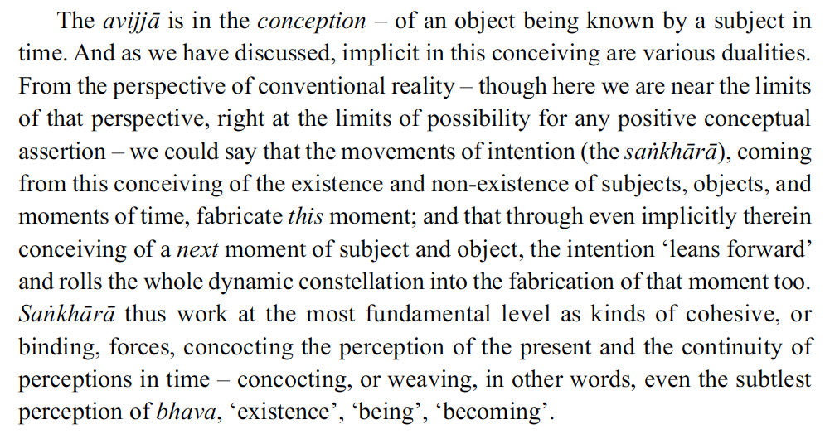

p.338, third paragraph:
Oops again… a strange mistake before; more accurate now with the Pali and Sanskrit grammar.

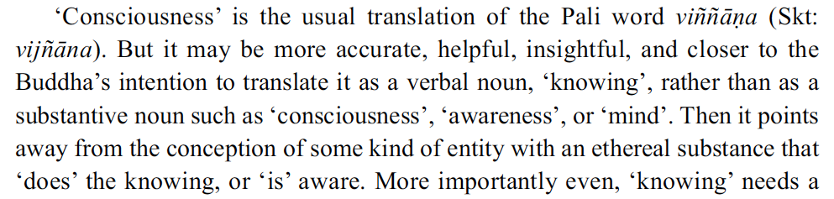
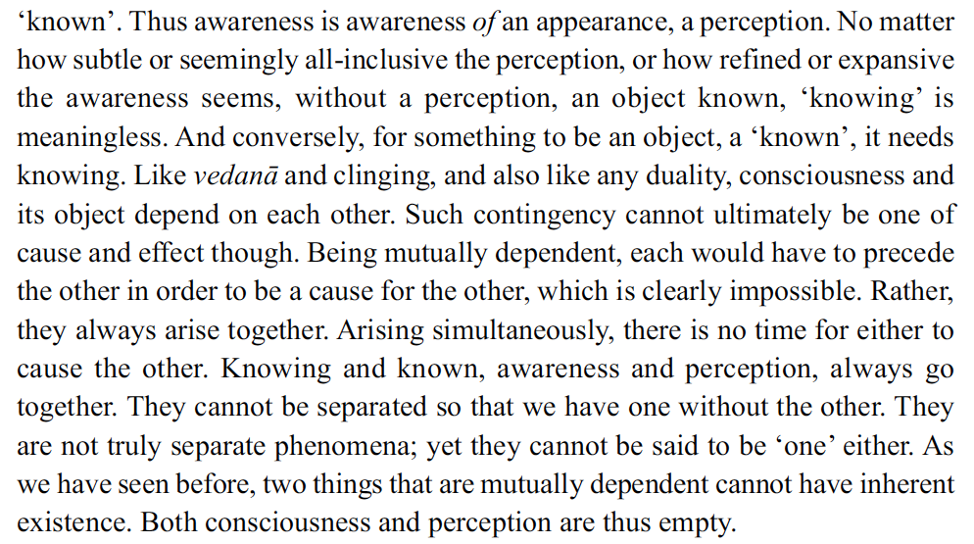
p.421, final paragraph:
The very minor change here was made on two accounts: in part to once again emphasize that awakening is not a static or singular state (just as it does not imply only one way of looking); and in part for more aesthetic reasons. The rhythm and all the subtle music of language are deeply important to me. So for example, endings in general, and then in particular the ending of a long book like this and the journey that it maps, demand, it seems to me, rhythmic cadences that support the message or content of what is communicated as well as a correspondingly particular feeling of ending. One of the hardest aspects for me in writing this book was having constantly to prioritize clarity of explanation over the poetry and music of the language. Still these latter were always devoted a great deal of intuitive consideration as I wrote and revised passages; but consistently relegating them, for the sake of the reader’s ease of understanding, from their usual position of priority felt to the ‘poet’ in me like a difficult sacrifice.
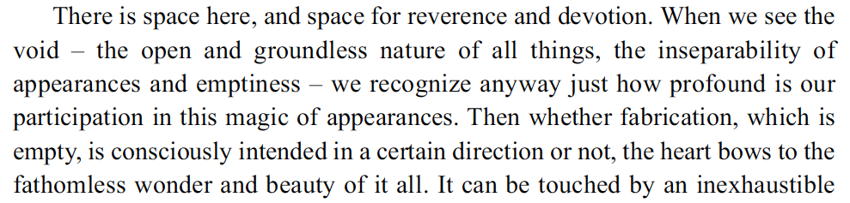
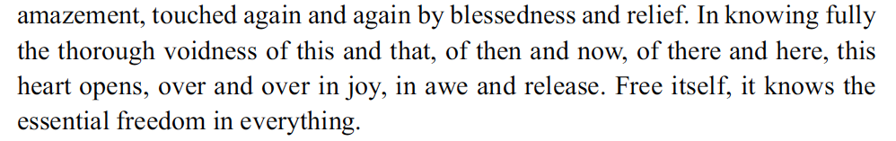

Bibliography:
A handful of entries that were accidentally omitted first time around have now been included.

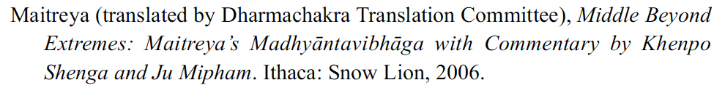

A number of other revisions have been made at various places in the text, but most of them are relatively minor.

Index:
There are some minor changes to the Index, some of which are merely due to the changes to the main body of text listed above.

Reflections and suggestions:
With respect to the Index, and also to the whole book, a few more general points may be helpful. First, just an obvious thing: a reminder that there is an Index. All kinds of questions will naturally come up for anyone working through the book, and in carefully compiling the Index I tried, based on my experience teaching this material, to anticipate these questions, so that searching through the Index entries for a key word related to your question should usually lead you to the answer to your question, or to helpful suggestions, etc. (Note that e-book and Kindle versions of Seeing That Frees do not come with the Index, as indexing is impossible in those flexible formats. The electronic versions have word-search functions, of course, but unfortunately that cannot allow the level of nuanced searching that the Index provides.)

Second, it’s easy with a book this size, that has so much in it and offers so many practices, to get a little bit lost in the detail and miss the bigger picture, the overarching framework of the whole. To me that is actually the most important dimension of the book. Yes, the details are important, but understanding how it all fits together – how the whole process of deepening insight actually works through the book – is the most important thing. Based on this, all the parts and details will be easier to understand. So as you read and work through the book, it may be really helpful to keep the big picture in mind and keep articulating to yourself how it all fits together. For some people, that kind of way of thinking, of learning, or digesting material is normal; for others much less so. But I would say that in this case it is indispensable; and that without understanding the bigger trajectory and how any particular piece fits into that whole trajectory, whatever understanding one has of that particular piece or detail is in fact incomplete, and often (because of not grasping the bigger picture) one probably won’t even realize that it is.

Related to this, it might be helpful sometimes (strange as it may sound) to actually scan slowly through the Index – not looking for any particular entry, but more with an eye to what entries are there. This can be a way of gaining almost a snapshot overview of the book. (Again, this won’t be possible with the e-book and Kindle versions.) Of course you can get a very rough sense of an overview by looking at the Contents page to see the titles of the sections and the chapters and grasp there the broadest brushstrokes of the larger unfolding; or, for a more detailed sense, by reading through in order just the first few paragraphs of each chapter, which often sum up briefly the journey up to that particular point before introducing something that builds on or adds to that. Surveying the Index, however, is like getting an alternative, and differently detailed, perspective on the whole book – noticing what themes, points, and connections are emphasized and therefore most significant, and so viewing its structure from a different angle, ‘from the rear’, so to speak. Just working instead through the main body of text slowly (or just reading it through without developing the practices) there will be perhaps for many readers more likelihood of not quite grasping the bigger picture and what actually are the most significant themes, points, and relationships.

I offer these reflections and suggestions based on my experience teaching, but even more on listening to many who have read the book and my discernment of what they have understood and what they have not yet understood. I think it’s fair to say that with just a single reading, most readers, even those who have done many years of practice, won’t grasp everything in the book. What’s more, most won’t adequately grasp the bigger picture of the approach. As mentioned above, this is the most important level of understanding, the one that will probably make the most difference. The book is certainly not intended to be only, or even primarily, a ‘compendium’ of practices. Nor is it just a book about the subjects of emptiness and dependent arising. It is more essentially a presentation of a certain way of thinking about and approaching the whole of the Dharma and practice, and that approach is probably unfamiliar to most. This need, then, for taking one’s time, really getting familiar with and gaining some skill with the various practices, making sure one understands the larger trajectory, and working through more than once is simply a reflection of the depth of the material covered, and the fact that the whole approach and the premises on which the book is based will most likely not be familiar to most readers. (Interestingly, sometimes it’s even harder for really long-term practitioners to grasp the basic principles and larger trajectory of the approach and how it works, because certain ways of conceiving of the Dharma and of practice have become entrenched over the years.) So I expect that the really significant fruits of working with the book will only be gained over time and perhaps over several workings through. Indeed my intention and sense in writing it was that it would be a book that would continue to reward the interested and involved reader for many years.

Also related to all this, it might be helpful to say a few more words here about supporting a deepening understanding, and about how we respond when we feel we don’t understand something. In our culture, patterns of self-blame, self-criticism, and even self-hate are so common and in many can be triggered sometimes just by the sense of not understanding something. So much could be said about this, about the workings of those painful patterns of self-criticism, possible skilful responses to them, and paths of healing. But I as well as many others have addressed this in detail elsewhere. Here I’d just like to offer three considerations that can be engaged if in working through this book one does encounter a sense of not understanding and is shaken by it.

- As mentioned above, it will probably be really helpful, if you feel you’ve reached a place in the trajectory you don’t understand, to review for yourself the bigger picture. Getting that clear in your mind will likely help in understanding any specific point or explanation in the book, just by giving it context and purpose in the larger unfolding of insight. In grasping the frame and trajectory of the larger approach, it should become very clear that the two conceptions the book primarily rests on are ‘fabrication’ and ‘ways of looking’. Indeed, following on from what was mentioned above, we might describe Seeing That Frees as a presentation of an integrated way of conceiving the whole of the Dharma and practice based on the interconnected concepts of ‘ways of looking’ and ‘fabrication’. Now, it may not be obvious at first but an approach and a way of thinking about the Dharma that is really and integrally based on these two ideas is actually from the start radically different, and will eventually open up very different possibilities, than one which only ever acknowledges the facts that it is at times possible for us to look at some things in different ways, and that some of our experience is indeed fabricated. So if the ways this book explains these two concepts themselves – of ‘ways of looking’ and of ‘fabrication’ – their relationship, and their integral and fundamental roles in structuring this journey of insight are not clear to you, it almost certainly means that you haven’t yet really comprehended the bigger picture of the approach. In that case I would recommend going back to review chapters 2 and 4, with an eye to getting clear about these two concepts, then seeing how the explanations there relate to chapters 11 and 19 (and eventually to other chapters, including 25, 27, and 29). Ploughing on when we actually don’t understand yet the bigger picture and basis of the approach will either result in the assumption that we have understood everything when we haven’t – which would be a really unfortunate obliviousness – or a feeling of nervousness because we sense that we are effectively lost and lacking a base on which to build or develop more. But if we get genuinely clear about the larger approach, then merely not understanding some smaller specific point won’t rock the boat so much.

- Sometimes something just won’t make sense because we are actually clinging, without realizing it, to some or other assumption that is forming a basis for our whole outlook. So for example, if somehow one is reading the book while actually unconsciously clinging to notions of ‘what is’, or that simple mindfulness can reveal and allow us to ‘be with what is’, this will block a deepening of the understanding. Or if one is clinging unconsciously to a basic assumption and perspective of ‘physicalism’ – specifically, of explaining perception and consciousness as fundamentally the results of material causes at a neurological level – that too will severely limit the deepening of insight into emptiness, and would also indicate that the whole approach and the premises of this book are not yet grasped. As is pointed out in Chapter 22, any investigation into anything must rest on some or other assumptions. And this book rests on different philosophical assumptions than physicalism. It takes perception, experience just as it appears, as its starting point without yet assuming any ‘base’ for it in something other, such as matter or neurology; and then, noticing that ways of looking and conceiving affect perception, investigates that relationship as far as possible. (Thus the approach the book presents could be described, in philosophical terms, as a kind of extended phenomenological investigation – one that has available to it, though, not just thinking and coarse observation but all the range and practical flexibility of ways of perceiving that meditation offers, which more traditional phenomenological philosophical inquiries do not.)

- Sometimes something at a certain point may not be making sense simply because one needs to develop more the practices that have led up to that point, to see something in one’s own experience for oneself, and then the explanation or the connection that is being made begins to make sense. So this too is worth checking and responding to accordingly – by taking more time or making sure that the practices before that point are bringing some freedom (they are ‘working’) and, as emphasized so often in the book, noticing what else they affect, i.e. the sense of self, or aspects of the perception of objects.

A lot more could be said about all this but I’ll stop here (before it turns into another book!). I hope that for those interested these changes, clarifications, reflections, and suggestions will be helpful.

RB
January 2016

